num = int(input("enter the number? \n"))

if num%2 == 0:

print("Number is even")

print("bye")

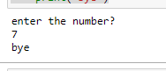

a = int(input("Enter a- "));

b = int(input("Enter b- "));

c = int(input("Enter c- "));

if a>b and a>c:

print("a is largest");

if b>a and b>c:

print("b is largest");

if c>a and c>b:

print("c is largest");

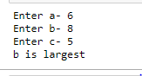

age = int (input("Enter your age?\n "))

if age>=18:

print("You are eligible to vote !!");

else:

print("Sorry! you have to wait !!");

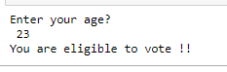

num = int(input("enter the number?\n"))

if num%2 == 0:

print("Number is even...")

else:

print("Number is odd...")

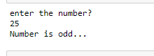

number = int(input("Enter the number?\n"))

if number==10:

print("number is equals to 10")

elif number==50:

print("number is equal to 50");

elif number==100:

print("number is equal to 100");

else:

print("number is not equal to 10, 50 or 100");

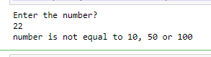

number = input("Enter the number?")

if number==10:

print("number is equals to 10")

elif number==50:

print("number is equal to 50");

elif number==100:

print("number is equal to 100");

else:

print("number is not equal to 10, 50 or 100");

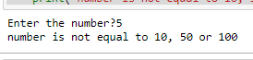

marks = int(input("Enter the marks? "))

if marks > 85 and marks <= 100:

print("Congrats ! you scored grade A ...")

elif marks > 60 and marks <= 85:

print("You scored grade B + ...")

elif marks > 40 and marks <= 60:

print("You scored grade B ...")

elif (marks > 30 and marks <= 40):

print("You scored grade C ...")

else:

print("Sorry you are fail ?")

